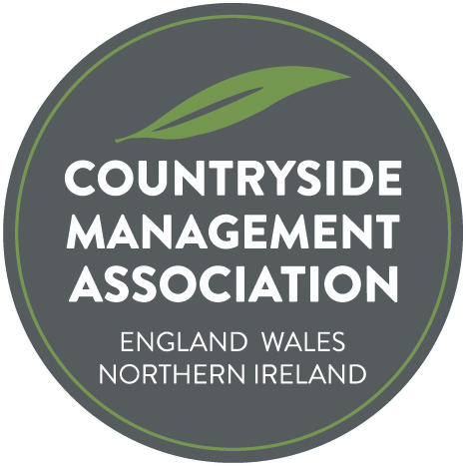
Gordon Miller Award – Submission Form

Nomination Form

The search is underway to find the most deserving project, initiative or innovative practice that has made or is making an outstanding contribution to countryside/urban greenspace management for the Gordon Miller Award. The Award is presented annually, with the ‘trophy’ being passed to the next recipient.

Until his death in 2024, Gordon Miller was President of the CMA. He devoted his life to the protection of the global environment, its fauna and flora and the defence of the world’s special places. During his chairmanship of the Association of National Park and Countryside Rangers, he launched Ranger magazine. In 1992, the Association formed the International Ranger Federation (IRF) and Gordon became its first president. His wide experience and infectious enthusiasm continue to inspire all those engaged in defending the world’s protected areas.

This award in his name, is a way of acknowledging the hard work and commitment of people who contribute to making the UK's countryside and urban greenspace a wonderful and inspiring place to visit, live and work in. Each year CMA will look for a person or a group of people for whom sharing their knowledge, skills, experience and enthusiasm has resulted in an exceptional contribution to the management of the countryside and/or urban greenspace of the UK.

The Ranger magazine already highlights great work from around the country. Each of the projects submitted will receive acknowledgement and feature in the Ranger and on the website. Let’s take some time to promote and celebrate great work whether it’s through members, organisations, volunteers or partners working together.

The project doesn’t have to have started during the last year, although it may have done. In fact it may have been running for a few or several years. Important elements are likely to be innovative ideas, people working together, environmental sustainability, habitat protection, biodiversity enhancements, community engagement and whether the project achieved its original aims.

Nominations can be projects, initiatives or innovative practices that have resulted in positive improvements for habitats, species, access or people (education or interpretation). Nominations can be for employers, other organisations / groups, volunteers or individual countryside management staff. You can nominate a person or organisation that you feel deserves to be the winner of this year’s Award, or you can put one of your own projects forward. Nominees do not have to be members of the CMA.

Nominations should be made by completing the form overleaf and returning to admin@countrysidemanagement.org.uk.

The award is presented at the CMA’s annual conference. Entrants will be asked to send a brief presentation, saved as a PDF, to be shared with CMA members who will be asked to vote for their preferred choice as award winner. For transparency and to avoid bias, members of the CMA Board may not submit an entry.

Countryside Management Association
Gordon Miller Award – Nomination Form

Nominee
Name of individual, organisation or project being nominated:

Where is the activity/project being carried out? (location & region)

Nominee Contact details – CMA needs to be able to contact someone about this nomination
(NB these personal details will not be published without explicit permission)
Primary contact name:
Address:
Town/City:
County:
Postcode:
Email:
Phone number:

Your contact details (if different to above)
Contact name:
Email:

About the activity/work/project
Summary
(150 words max)
Please summarise the work/project, being clear about what was achieved and the difference the project has made.

This will be used on the web site and in Ranger to describe your project.

What did the work involve
(650 words max)
Please describe the work/project in more detail

What were the outputs and outcomes?
Please provide facts and figures (eg. no of schools or volunteers engaged, events delivered, acres improved, joint working)

Innovative? Demonstrates best practice?

Sell the project!!

(100 words max)
Please state clearly why you feel the project should win this award.

If appropriate:
(150 words max) who was involved? Partners? Employers? Vols?
Funding?
Downloads, videos, images | Please send 2 -3 copyright free images to accompany your entry, or other downloads/videos. These will be used on the CMA website, in Ranger magazine and wider promotion eg press releases. Please only send images that have permission to use and state any required credit(s). Email pictures with Nomination Form to: admin@countrysidemanagement.org.uk

Permissions:

By submitting this form you agree to CMA storing the information for the purposes of administering the Award.

By submitting this form you agree to CMA publishing the information provided on the form, photographs or video (but not the personal details without permission) to publicise the Award and your work. CMA is happy to discuss specifics that should not be publicised (names/details/photos)

Signature:

Name: Date:

