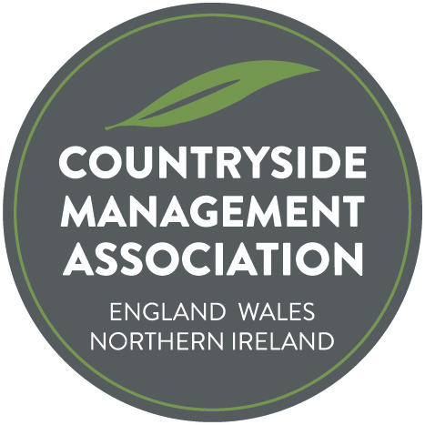
George Mist Award for Woodland Magic

Submission Form

Nomination Form

The search is underway to find the most deserving project, initiative or innovative practice that has made or is making an outstanding contribution to the conservation, management or community/educational use of woodland for the George Mist ‘Woodland Magic’ Award.

2025 will be the first presentation of this new award, which will thereafter be presented annually, with the ‘trophy’ being passed to the next recipient. George Mist was made an Honorary Fellow of the CMA for his many decades of stalwart work within woodlands, with communities and for his unwavering encouragement and support to fellow rangers, especially the younger generation. The trophy has been crafted by George himself to award to those who follow in his footsteps.

The Award is a way of acknowledging the hard work and commitment of people who contribute to protecting, enhancing and promoting the UK's woodland. Each year CMA will look for a person or a group of people for whom sharing their knowledge, skills, experience and enthusiasm has resulted in an exceptional contribution to the management of woodland within the countryside or urban greenspace of the UK. Let’s showcase the amazing woodland work that we all know takes place across England, Wales and Northern Ireland.

Each of the projects submitted will receive acknowledgement and feature in the Ranger and on the CMA website. Let’s take some time to promote and celebrate great work whether it’s through members, organisations, volunteers or partners working together.

The project doesn’t have to have started during the last year, although it may have done. In fact it may have been running for a few or several years. Important elements are likely to be innovative ideas, environmental sustainability, habitat protection, biodiversity enhancements, community engagement and whether the work achieved its original aims.

Nominations can be projects, initiatives or innovative practices that have resulted in positive improvements for woodland habitats, species, access or people (education or interpretation). Importantly, you’ll need to explain how the project has produced ‘Woodland Magic’.
Nominations can be for employers, other organisations / groups, volunteers or individual countryside management staff. You can nominate a person or organisation that you feel deserves to be the winner of this year’s Award, or you can put one of your own projects forward.
Nominees do not have to be members of the CMA.

Nominations should be made by completing the form overleaf and returning to admin@countrysidemanagement.org.uk.

The award is presented at the CMA’s annual conference. Entrants will be asked to send a brief presentation, saved as a PDF, to be shared with CMA members who will be asked to vote for their preferred choice as award winner.

Countryside Management Association
George Mist ‘Woodland Magic’ Award
Nomination Form

Nominee
Name of individual, organisation or project being nominated:

Where is the activity/project? (location & region):

Nominee Contact details – CMA needs to be able to contact someone about this nomination
(NB these personal details will not be published without explicit permission)
Primary contact name:
Address:
Town/City:
County:
Postcode:
Email:
Phone number:

Your contact details (if different to above)
Contact name:
Email:

About the activity/work/project
Summary
(150 words max)
Please summarise the woodland work/project, being clear about what was achieved and the difference the project has made.

This will be used on the web site and in Ranger to describe your project.

What did the work involve?
(650 words max)
Please describe the woodland work/project in more detail and…

What were the outputs and outcomes?
Please provide facts and figures (eg. no of schools or volunteers engaged, events delivered, acres improved, joint working)

Innovative? Demonstrates best practice?

Sell the project!!

(100 words max)
Please state clearly why you feel the project has resulted in ‘Woodland Magic’.
If appropriate:
(150 words max) who was involved? Partners? Employers? Vols?
Funding?
Downloads, videos, images | Please send 2 -3 copyright free images to accompany your entry, or other downloads/videos. These will be used on the CMA website, in Ranger magazine and wider promotion eg press releases. Please only send images that have permission to use and state any required credit(s). Email pictures with Nomination Form to: admin@countrysidemanagement.org.uk

Permissions:

By submitting this form you agree to CMA storing the information for the purposes of administering the Award.

By submitting this form you agree to CMA publishing the information provided on the form, photographs or video (but not the personal details without permission) to publicise the Award and your work. CMA is happy to discuss specifics that should not be publicised (names/details/photos)

Signature:

Name: Date:

