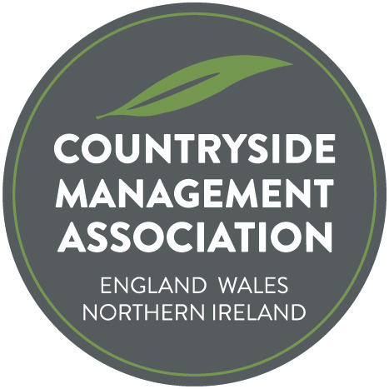
Gordon Miller Award – Submission Form

Nomination Form

The search is underway to find the most deserving project, initiative or innovative practice that has made or is making an outstanding contribution to countryside/urban greenspace management for the Gordon Miller Award. The Award is presented annually, with the elegant barn owl trophy being passed to the next recipient.

The Award is a way of acknowledging the hard work and commitment of people who contribute to making the UK's countryside and urban greenspace a wonderful and inspiring place to visit, live and work in. Each year CMA will look for a person or a group of people for whom sharing their knowledge, skills, experience and enthusiasm has resulted in an exceptional contribution to the management of the countryside and/or urban greenspace of the UK.

The aim is very much to encourage great projects that everyone can see and hear about; showcasing the fabulous work that we all know takes place around the land. Each of the projects submitted will receive acknowledgement and feature in the Ranger and on the web site. Let’s take some time to promote and celebrate great work whether it’s through members, organisations, volunteers or partners working together.

The project may have been running for several years or a short term initiative. Important elements are innovative ideas, people working together, commitment, and the results or outcomes of the project.

Nominations can be projects or initiatives that have resulted in positive improvements for habitats, species, access or people (education or interpretation). Nominations can be for employers, other organisations / groups, volunteers or individual countryside management staff. You can nominate a person or organisation that you feel deserves to be the winner of this year’s Award, or you can put forward one of your own projects.

Nominations should be made by completing the form below and returning to admin@countrysidemanagement.org.uk by end midnight on 12th October

In addition to the nomination form below, we ask that you also send a PDF document or a brief powerpoint presentation, saved as a PDF. These will be shared with CMA members, who will be asked to vote for their preferred choice as award winner.

Countryside Management Association
Gordon Miller Award – Nomination Form

Nominee
Name of individual, organisation or project being nominated:

Where is the activity/project being carried out? (location & region)

Nominee Contact details – CMA needs to be able to contact someone about this nomination
(NB these personal details will not be published without explicit permission)
Primary contact name:
Address:
Town/City:
County:
Postcode:
Email:
Phone number:

Your contact details (if different to above)
Contact name:
Email:

About the activity/work/project
Summary
(150 words max)
Please summarise the work/project, being clear about what was achieved and the difference the project has made.

This will be used on the web site and in Ranger to describe your project.

What was done
(500 words max)
Please describe the work/project in more detail
Downloads, videos, images | Please send 2 -3 copyright free images to accompany your entry, or other downloads/videos. These will be used on the CMA website, in Ranger magazine and wider promotion eg press releases. Please only send images that have permission to use and state any required credit(s). Email pictures with Nomination Form to: admin@countrysidemanagement.org.uk

Permissions:

By submitting this form you agree to CMA storing the information for the purposes of administering the Award.

By submitting this form you agree to CMA publishing the information provided on the form, photographs or video (but not the personal details without permission) to publicise the Award and your work. CMA is happy to discuss specifics that should not be publicised (names/details/photos)

Signature:

Name: Date:

