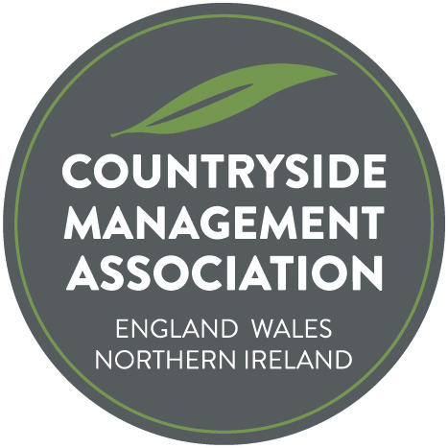
Gordon Miller Award – Submission Form

Nomination Form

The search is underway to find the most deserving project, initiative or innovative practice that has made or is making an outstanding contribution to countryside/urban greenspace management for the Gordon Miller Award. The Award is presented annually, with the ‘trophy’ being passed to the next recipient.

The Award is a way of acknowledging the hard work and commitment of people who contribute to making the UK's countryside and urban greenspace a wonderful and inspiring place to visit, live and work in. Each year CMA will look for a person or a group of people for whom sharing their knowledge, skills, experience and enthusiasm has resulted in an exceptional contribution to the management of the countryside and/or urban greenspace of the UK.

The intention is not to introduce a highly competitive ‘winner/loser’ scenario; the aim is very much to encourage members to put forward great projects that everyone can see and hear about; showcasing the fabulous work that we all know takes place around the land. The Ranger magazine already highlights great work from around the country. Each of the projects submitted will receive acknowledgement and feature in the Ranger and on the web site. Let’s take some time to promote and celebrate great work whether it’s through members, organisations, volunteers or partners working together.

The project doesn’t have to have started during the last year, although it may have done. In fact it may have been running for a few or several years. Important elements are likely to be innovative ideas, people working together, commitment, time & effort, results or outcomes of the project.

Nominations can be projects, initiatives or innovative practices that have resulted in positive improvements for habitats, species, access or people (education or interpretation). Nominations can be for employers, other organisations / groups, volunteers or individual countryside management staff. You can nominate a person or organisation that you feel deserves to be the winner of this year’s Award, or you can put one of your own projects forward.

Nominations should be made by completing the form overleaf and returning to admin@countrysidemanagement.org.uk.

The award is presented at the CMA’s annual conference and entrants will be asked to deliver a brief presentation. In addition to the nomination form below however, we recommend that you also send your powerpoint presentation, saved as a PDF. These will be shared with CMA members
who at/following the conference will be asked to vote for their preferred choice as award winner.

Countryside Management Association
Gordon Miller Award – Nomination Form

Nominee
Name of individual, organisation or project being nominated:

Where is the activity/project being carried out? (location & region)

Nominee Contact details – CMA needs to be able to contact someone about this nomination
(NB these personal details will not be published without explicit permission)
Primary contact name:
Address:
Town/City:
County:
Postcode:
Email:
Phone number:

Your contact details (if different to above)
Contact name:
Email:

About the activity/work/project
Summary
(150 words max)
Please summarise the work/project, being clear about what was achieved and the difference the project has made.

This will be used on the web site and in Ranger to describe your project.

What was done
(500 words max)
Please describe the work/project in more detail
Outputs/Outcomes (300 words max)
Please provide some facts and figures (e.g. no of schools / vols engaged, events delivered, acres improved /joint working),
how the project was innovative or demonstrates best practice.

Sell your project!

If appropriate:
(150 words max) who was involved? Partners? Employers? Vols?
Funding?
Downloads, videos, images | Please send 2 -3 copyright free images to accompany your entry, or other downloads/videos. These will be used on the CMA website, in Ranger magazine and wider promotion eg press releases. Please only send images that have permission to use and state any required credit(s). Email pictures with Nomination Form to: admin@countrysidemanagement.org.uk

Permissions:

By submitting this form you agree to CMA storing the information for the purposes of administering the Award.

By submitting this form you agree to CMA publishing the information provided on the form, photographs or video (but not the personal details without permission) to publicise the Award and your work. CMA is happy to discuss specifics that should not be publicised (names/details/photos)

Signature:

Name: Date:

