Event title:
Location:
Date:
Start and finish time:
Event description

Please also attach a photo to your email, please ensure that this image is copyright free, that you have full permission for its use.

Food and refreshments:
Name of organiser:
Contact number(s):
Contact email:
The CMA uses Eventbrite as our booking system for study days. In order to receive automated emails about bookings and delegates, the above person will be set up as a sub-user on Eventbrite. If you would prefer someone else to do this instead/as well, please give their email below:
Alternative email:
Instead/As well (please delete accordingly)
Host organisation(s):
Event covered by host’s public liability insurance?
Fee for CMA members:
Fee for non CMA members: | Members’ fee + £40. Please indicate if different
Minimum and Maximum number of people: | Min: 1 (change as necessary. See notes below)  Max:
Closing date for bookings:
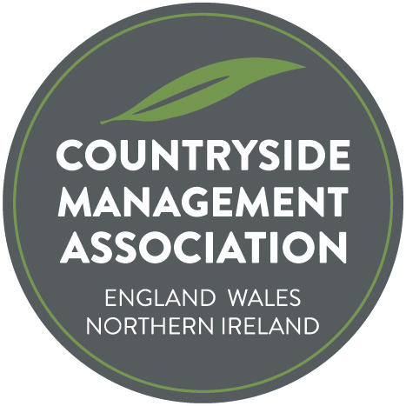
CMA Study Day and Training Event Proposal Form
Please see notes below before completing form

Once completed, please send form and photo(s) to admin@countrysidemanagement.org.uk copying in your regional co-ordinator (see About Us – Who’s Who on the website for contact details).
Notes – please read before completing form!
For advance listing of study days before all the details are decided,
the minimum information required is indicated by an asterisk*

Event title* | Ideally short, simple and self-explanatory
Location* | Include property name and postcode where possible, plus brief directions if necessary.
Date*
Start and finish time*
Event description*  Please also attach a photo to your email | Outline of itinerary and aims of the day. State whether the event is based indoors, outside or a mixture; and whether there is any significant physical activity involved.  We need a landscape-orientated photo for promoting the event on Eventbrite and the CMA website, ideally 1MB – 5MB in size.  An additional photo (portrait or landscape) can also be added within the body of text on the Eventbrite page, if supplied. Please ensure all photos/video/imagery supplied has full copyright, ie that you have full permission for its use.
Food and refreshments: | Tea/coffee provided? Bring packed lunch? On-site café available?
Name of organiser* | The person organising the event
Contact number(s)* | Ideally a daytime landline and mobile
Contact email* | Please state if you have a preference for whether email and/or phone number(s) are provided in event publicity, so that potential participants can ask questions.
The CMA uses Eventbrite as our booking system for study days. In order to receive automated emails about bookings and delegates, the above person will be set up as a sub-user on Eventbrite. If you would prefer someone else to do this instead/as well, please give their email below
Alternative email:
Instead/As well (please delete accordingly)
Host organisation(s) | Usually the organiser’s employer, but sometimes a different organisation which owns the host site or manages a project
Event covered by host’s public liability insurance? | CMA events are covered by CMA insurance but we may be able to reduce our premiums in future years if we can show that the majority of events are covered by host organisation’s insurance policies.
Fee for CMA members? | Unless you require any contribution from the fee for unavoidable expenses (venue hire, professional tutor etc.) CMA will retain any income to support the organisation. Standard arrangement is CMA members (and NT staff if NT-organised event) free, non-members £40. Please contact National Training Co-ordinator at the outset if costs will be incurred or a charge for CMA members is proposed.
Fee for non CMA members | Members’ fee + £40. Please indicate if different
Minimum and Maximum number of people | Please state if you will only run the event with a minimum number of people. And if there is a limit to the number of people you can accommodate.
Closing date for bookings | Usually sometime the week before, but can be earlier if essential, or later

